Suggestions for Using the Kit Resources

1. Animal Life Cycles

The kit contains 4 different resources for investigating animal life cycles:
- Foam jigsaw models of butterfly, bee and frog life cycles.
- Life Sequence Card Sets (butterfly, frog, chicken, mouse). These can be arranged in order and used to observe and describe the changes that occur as animals grow.
- Life Cycle Shapes (chicken, frog, butterfly). These can be placed in the correct positions on the laminated posters.
- Butterfly Life Cycle Kit. The larger-than-life plastic models can be arranged in order on the correct habitat photograph and labelled appropriately.

Extension activities
- During the spring, summer and early autumn, a mini ‘butterfly garden’ can be created outside by growing a selection of nectar-producing plants (in pots if necessary) that attract butterflies. Good examples include: polyanthus, primrose, wallflower, lavender, catmint, phlox, buddleia, cornflower, scabious, marjoram, aster, sedum.

Cabbage and nasturtium plants are excellent for attracting Large White butterflies, which lay their eggs on the underside of the leaves from May to July. The caterpillars can then be observed when the eggs hatch.

- Small amounts of frogspawn can be kept in a tank in the classroom with waterweed for food – or better still in a small pond. Once the tadpoles become carnivorous it is better to return them to a pond.

- The Schools Department Technician at Easton College can provide information and equipment for incubating and hatching eggs in the classroom. For further details contact Ruth Cannon on 01603 731257 or rcannon@easton-college.ac.uk

2. Plant Life Cycles

- The Apple Tree Life Sequence Card Sets can be arranged in order and used to observe and discuss the changes that take place during plant life cycles. This activity can be extended by providing real specimens of pips and fruit and making regular observations of a real apple tree throughout the year.

- The hand lenses can be used to observe the detailed structure of flowers. Plants with large flowers, such as lilies, are readily available in supermarkets and are good for looking at stamens, pollen grains and stigmas. The laminated photographs show pollen grains highly magnified using a scanning electron microscope, which shows the surface detail, and pollen grains which have started to produce pollen tubes to allow the pollen nucleus to reach the egg nucleus in the ovary and fertilise it (photographed using a light microscope)

- The Root Viewer Kit can be used to grow carrot, onion and radish plants from seed. Instructions are given in the kit.

- The Radish and Pea Growing Kit can be used with the Lightbank (Kit 2 only at 30.11.07) to grow radishes (from seed to radish) and peas (from seed to pea pod) in about 4 weeks at any time of the year. Full instructions are given in the kit.

- The Rapid Cycling Brassica Growing Kit is designed to be used with the Lightbank to grow the specially bred Brassica rapa seeds through a complete life cycle in about 5 weeks at any time of the year. Full instructions are given in the kit. Brassica rapa is a member of the cabbage family of plants and the subject of much research at JIC

- Investigate the changes that occur as a broad bean seed germinates and produces a new plant. Cut a cylinder of blotting paper to fit snugly inside a jam jar. Add about a 2cm depth of water to the jar and wait for the blotting paper to become damp. Wedge a broad bean seed (soaked overnight in water if possible) between the paper and the side of the jar, about halfway up. Stand in a warm place and keep the water level topped up to 2cm. This simple activity can be extended to investigate the effects of light and dark or different temperatures on plant growth and development
Background Information

The Butterfly Life Cycle (see also page 18)

All butterflies go through a complex life cycle that consists of four distinct developmental stages : egg, larva (or caterpillar), pupa (or chrysalis) and adult. It is an example of complete metamorphosis because the larva undergoes one very dramatic change into the adult. The transformation is so great that it requires a so-called ‘resting stage’ – the pupa.

- Female butterflies lay large numbers of tiny eggs, usually on the underside of the leaves of a specific host plant.
- In 1-2 weeks the eggs hatch to release tiny caterpillars or larvae, which start to feed on the host plant. The caterpillars have powerful jaws to tear up vegetation. Their job is to eat and grow.
- Caterpillars have external skeletons and so, in order to grow, they must shed this outer layer, a process called moulting. A caterpillar may moult several times and after each moult it changes considerably in size and appearance.
- When it is fully grown (1-3 weeks), the caterpillar looks for a suitable place to pupate. Most attach themselves to a twig by a silk thread that they spin themselves. The caterpillar then turns into a pupa.
- Inside the pupa, an amazing metamorphosis (change in form) takes place. Larval structures are completely broken down and totally reorganised to form an adult butterfly.
- When conditions are right ( after 1-3 weeks, or overwinter), the pupa splits open and the adult butterfly slowly emerges. At first its wings are wet, small and crumpled. They rapidly dry out and expand as the butterfly pumps blood through the veins in each wing. Within an hour or so, its wings are fully developed and the butterfly is ready to fly.
- The adult has a long coiled proboscis that it uses to suck up nectar from flowers. It flies around to find food and a mate. Its job is to reproduce and start a new life cycle.

By having two different ‘active’ stages in its life cycle – the caterpillar and adult, the butterfly is able to take advantage of two different food sources (leaves and nectar)

The Frog Life Cycle (see also page 16)

The frog’s life cycle also involves metamorphosis. The eggs hatch into an immature larval form called a tadpole, which eventually undergoes metamorphosis to become a small frog. Since the change from tadpole to adult is a more gradual process, it is called incomplete metamorphosis. Frogs are amphibians and need to reproduce in water.

- In spring, male frogs croak to attract females, swollen with eggs, to a pond. The male mounts the back of the female and they swim around in this position for several days until the eggs and sperm are deposited. Fertilisation is external and must take place in water. Huge numbers of eggs are produced but only a few will eventually develop into adults because many are eaten by predators, e.g. ducks.
- The eggs are surrounded by a jelly-like covering that swells in contact with water and protects the developing egg. The single cell inside the egg undergoes a series of divisions to form an embryo, which is nourished by the egg yolk.
- After about 3 weeks, the egg hatches and a tiny tadpole emerges. It attaches itself to water weed with mucus from its cement gland. It develops a mouth, which it uses to feed on algae, external gills to extract oxygen from the water and a tail for swimming.
- Gradually,the external gills disappear, having been replaced by internal ones. The hind legs begin to form.
- The tadpole develops strong jaws for a carnivorous diet. The front legs begin to form and the lungs start to develop, preparing the animal for its life on land.
- During metamorphosis, the tadpole becomes more froglike. It loses its jaws and its mouth widens. The tail becomes smaller and smaller and the legs grow. The lungs develop fully.
- About 11 weeks after the egg was laid, a fully developed small frog emerges from the water. It is able to use its lungs to extract oxygen from the air and it eats worms and insects, using its long, sticky tongue to catch them. The frog will live mostly on land, with occasional swims. Its skin must be kept moist as it is used in addition to the lungs for gas exchange. It may take up to 4 years to reach maturity and mate.

The Chicken Life Cycle

- The egg is fertilised internally in the female’s oviduct. The eggshell is deposited around the egg in the lower part of the oviduct, just before it is laid. The shell is made of calcite, a form of calcium carbonate. It forms a hard protective coating around the egg but allows oxygen to diffuse in and carbon dioxide to diffuse out.
- The embryo develops inside the egg for 21 days, during which time it is nourished by the yolk. The egg white cushions the embryo and prevents it from rubbing against the hard shell. The mother hen sits on the eggs to keep them warm and turns them regularly to prevent the yolk with developing embryo floating against the shell.
- At the end of this incubation period the chick pecks its way out of the egg using a special egg tooth on its beak. The newly hatched chick is wet and tired and rests for some time until its feathers have dried out. It is able to see, run around and feed itself.
- As the chick grows, its soft down is gradually replaced by feathers. Eventually the comb and wattles develop and the bird is a fully grown adult, able to reproduce.

The Mouse Life Cycle

Mice are mammals, the only group of animals that do not lay eggs. They give birth to live young, which develop inside the mother’s body in the uterus. When the young are born they are fed on milk produced by the mother’s mammary glands

- After mating, the fertilised eggs develop inside the uterus for about 3 weeks.
- The newborn mice are blind and furless and rely on their mother to keep them warm and feed them with her milk.
- Fur starts to grow about 3 days after birth and the eyes open 1 to 2 weeks after birth.
- Female mice reach sexual maturity at about 6 weeks and males at about 8 weeks. One female can produce between 5 and 10 litters per year and the average litter size is 6 – 8, so the population size can increase very quickly if canditions are favourable.

The combination of internal fertilisaton, internal development (mammals)
and parental care of offspring seen in birds and mammals means that their young have a higher chance of survival and so fewer eggs are produced.
The Flowering Plant Life Cycle

Flowering plants produce seeds, which will germinate and grow into new plants given the correct conditions of warmth, water and oxygen. Light is not needed for germination to occur.

The seed contains a foodstore and embryo root and shoot. The root develops first, followed by the shoot. Once the seedling has developed leaves it is able to carry out photosynthesis and produce its own food. Light is essential at this stage.

The plant eventually produces flowers, which may be scented and brightly coloured to attract insects for pollination. Wind-pollinated flowers are small and inconspicuous with long, dangling anthers and feathery stigmas. Pollen grains, containing the male sex cells, are produced by the anthers. The pollen is transferred by insects or the wind to the stigma in the centre of the flower. The pollen grain produces a long tube that grows down from the stigma into the ovary. The male sex cell can then travel down the pollen tube to fertilise the female sex cell (ovule) in the ovary.

The fertilised ovules develop into seeds and the ovary wall either dries out or becomes fleshy to form the fruit. The remaining flower parts wither and die.

The fruit is used to disperse the seeds from the parent plant. If it is fleshy it may be eaten by animals and the seeds later egested in droppings. If it is dry it may split open and fling out the seeds.

The Light Bank

The light bank contains 4 cool white fluorescent tubes which are ideal for growing plants with short life cycles indoors. The rapid cycling Brassica Rapa plants have been bred for their short life cycle, small size and high seed production. Given continuous light under the light bank, they will go through a complete life cycle, from seed to seed, in 35 days. It is important to follow the growing instructions in the booklet provided to achieve the best results.

The light bank can also be used to grow other plants quickly and successfully at any time of the year. Pea and radish plants work well, as can be seen in the accompanying photographs.

Plants Grown under the Lightbank

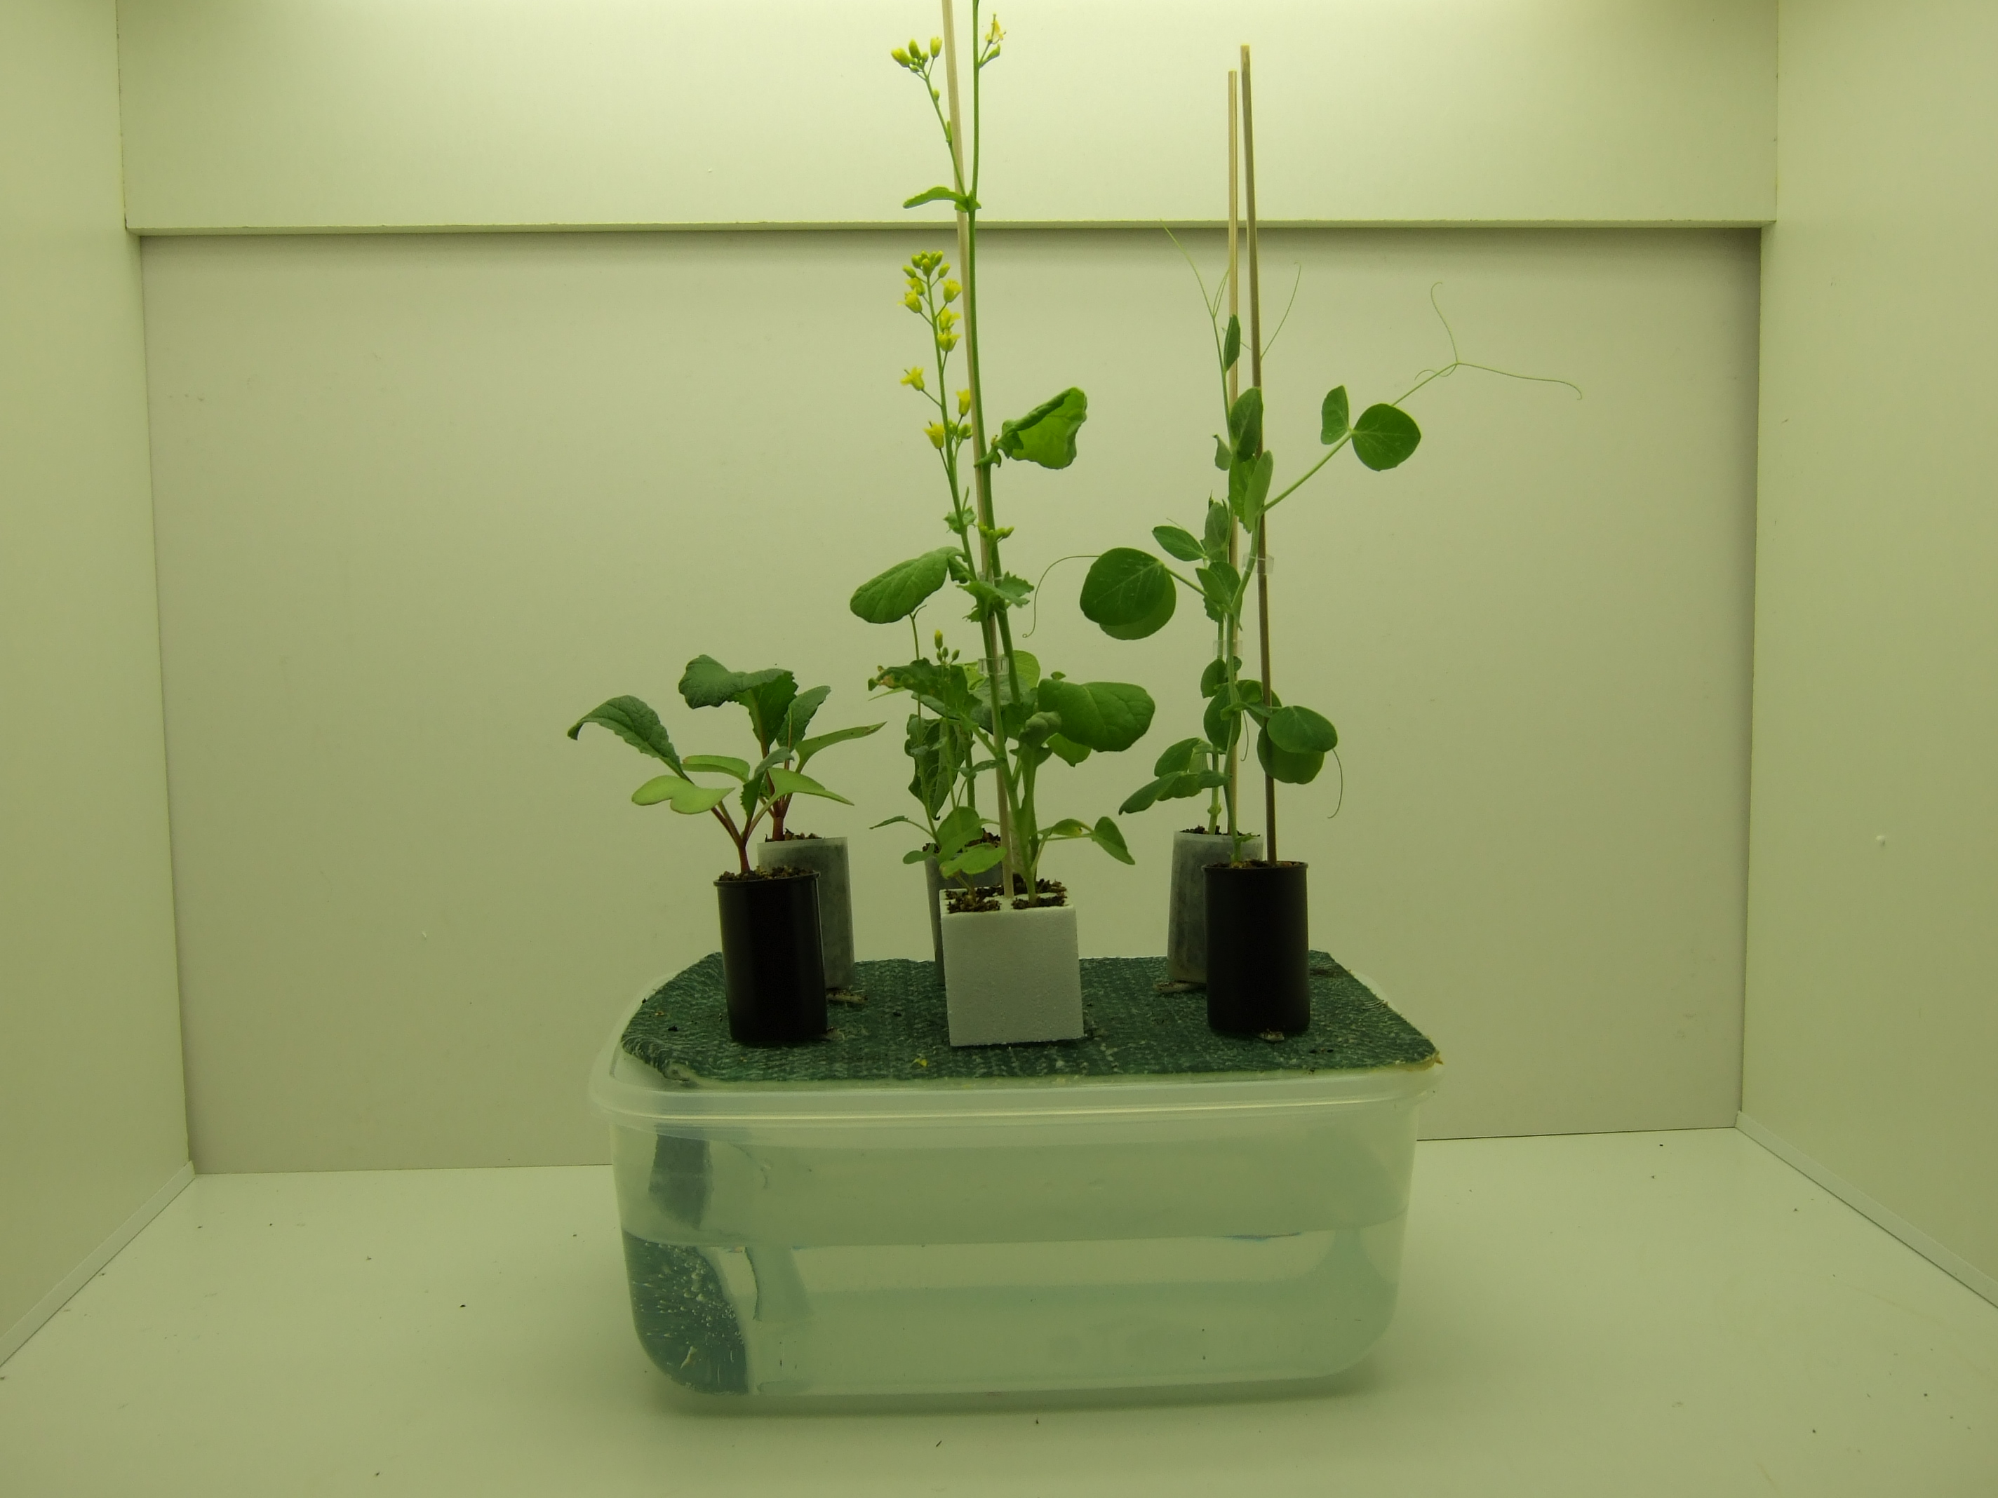

- Radish, pea and Brassica rapa plants 2 weeks after sowing seed

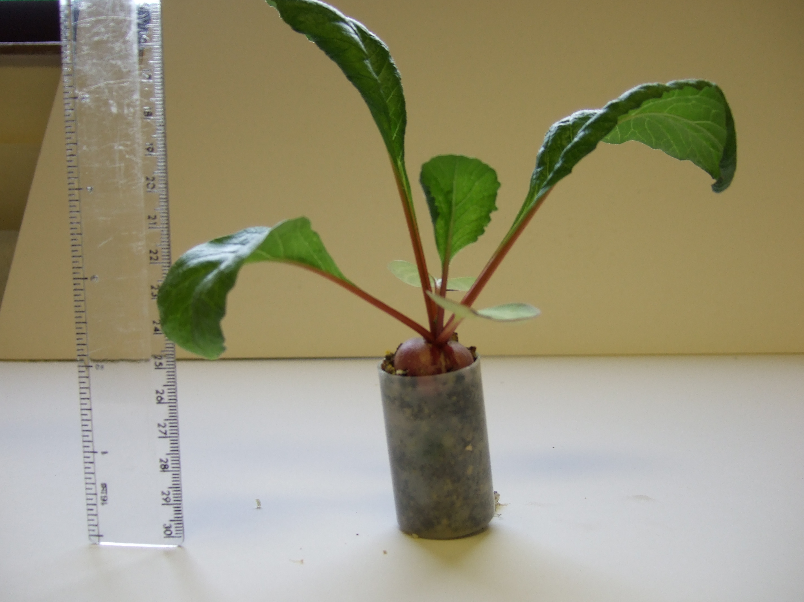

2. Radish plant 4 weeks after sowing seed

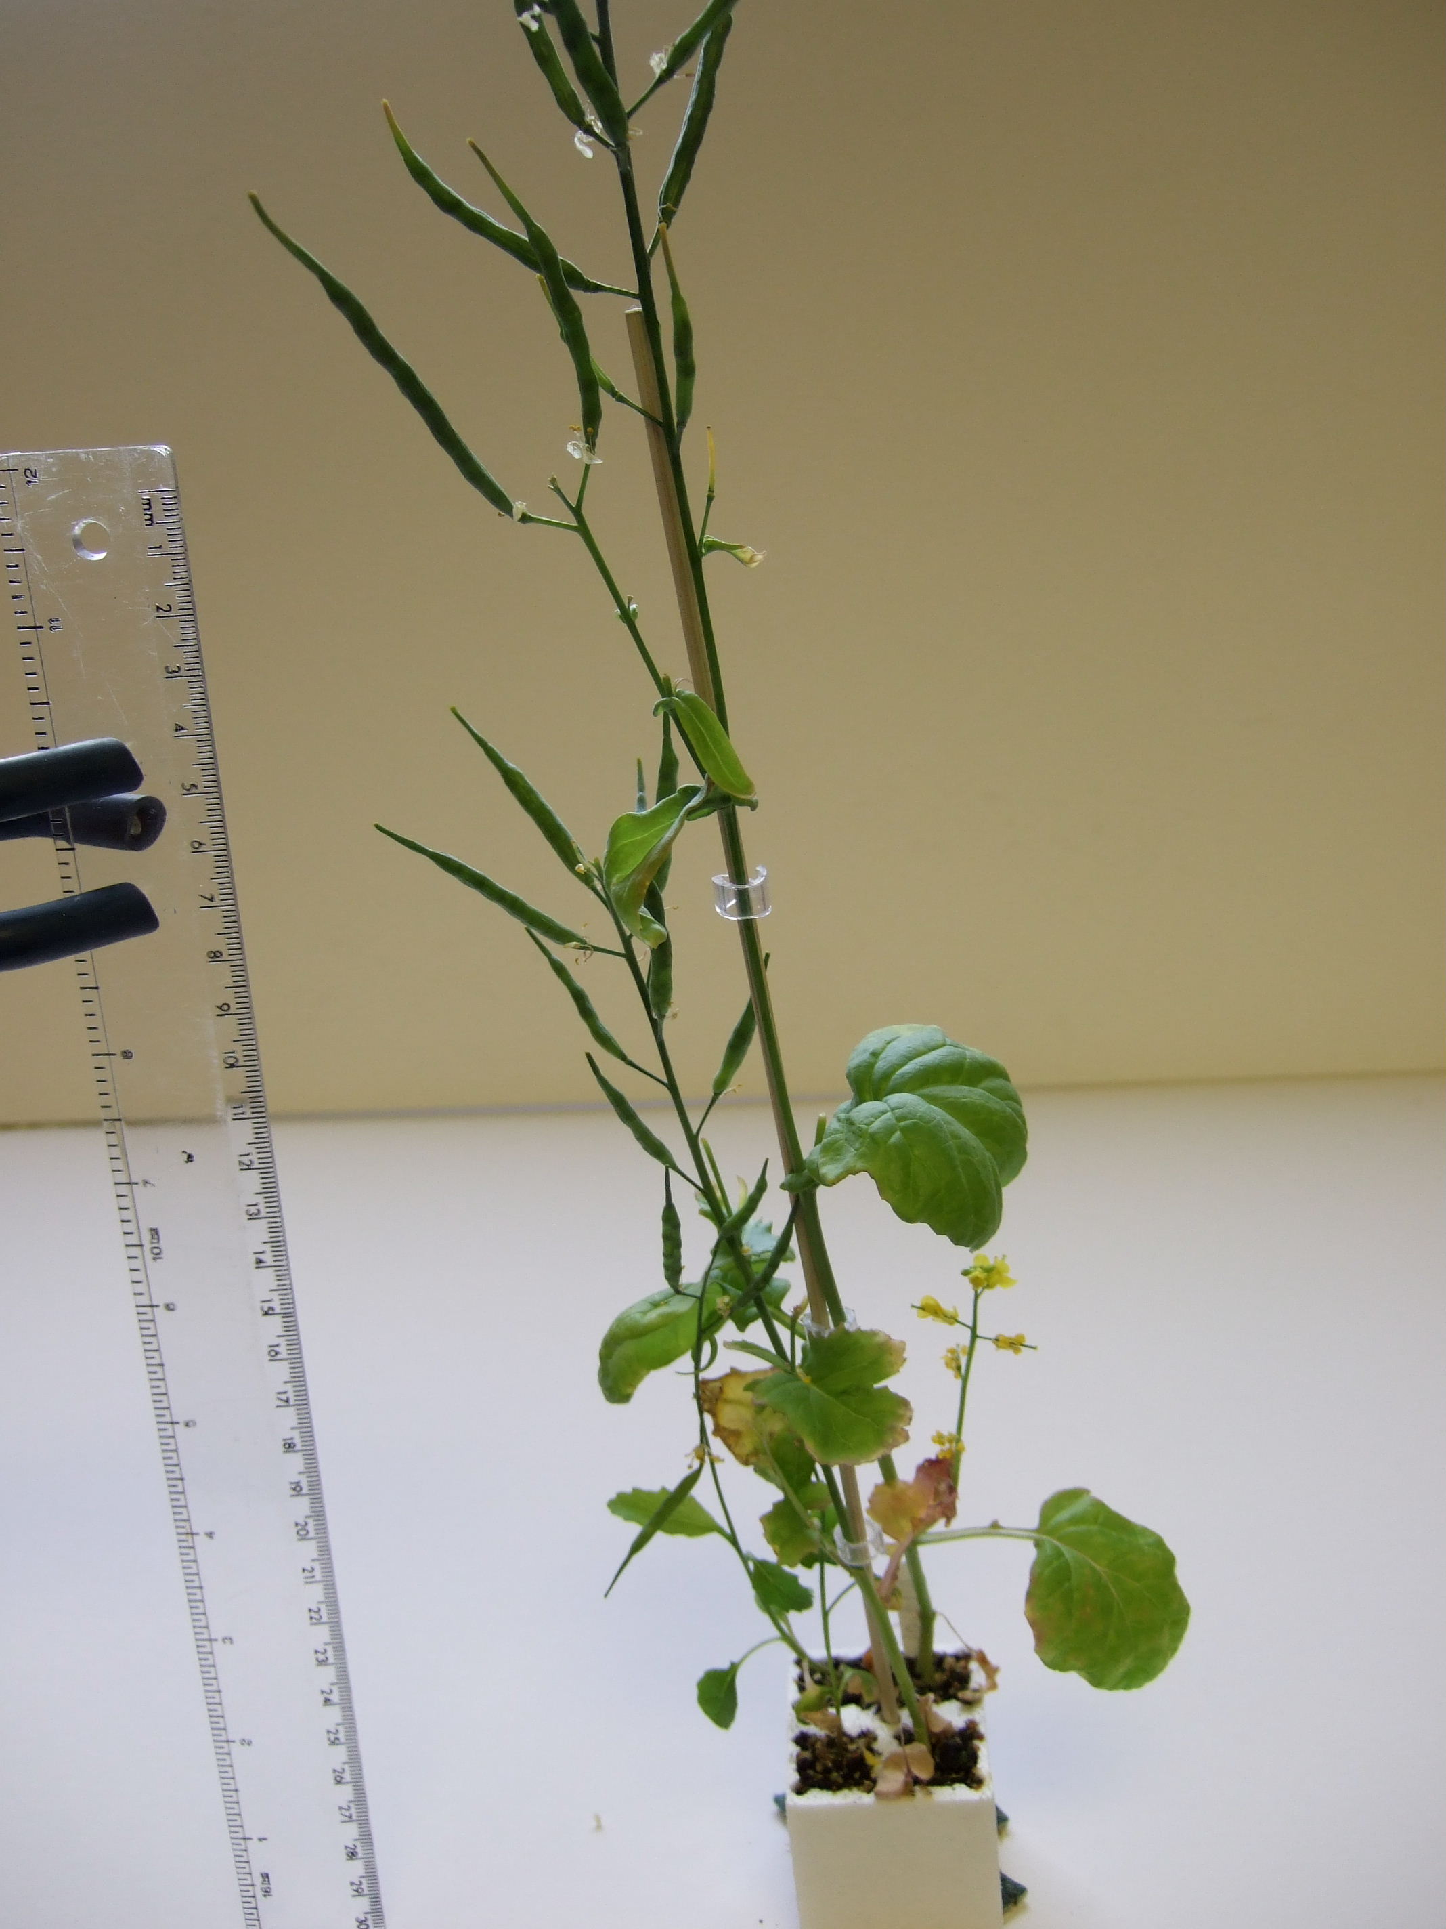

3. Brassica rapa, with seed pods, 4 weeks after sowing seed and pollinating with ‘beesticks’

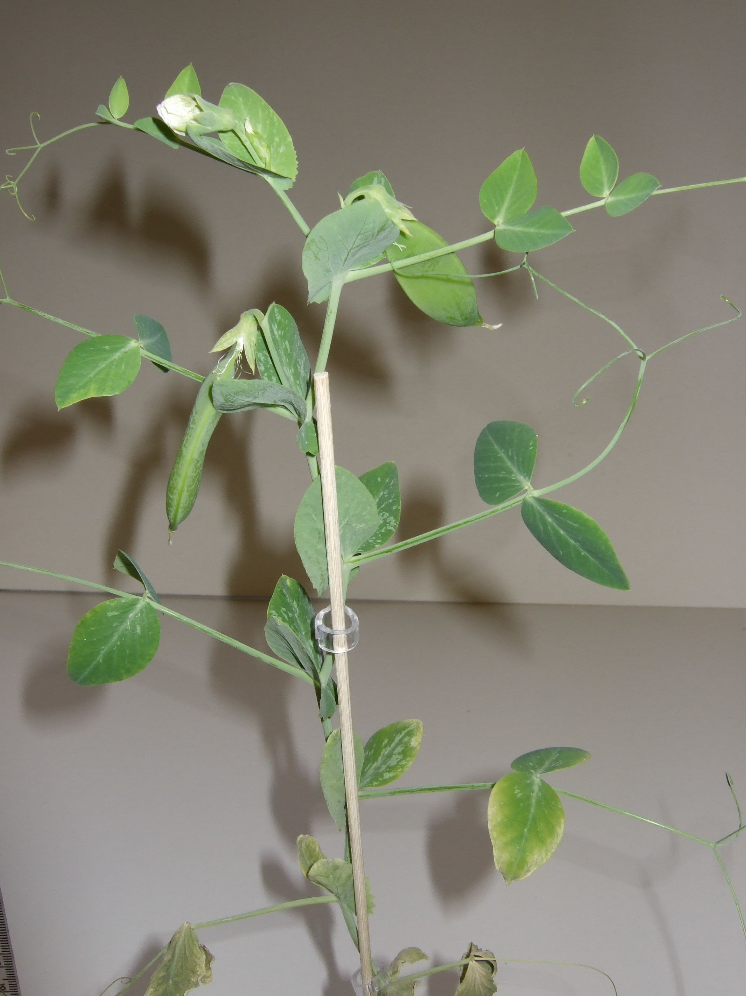

4. Pea plant, with flowers and pods, 4 weeks after sowing seed.
(Unlike B. rapa, this plant is able to self-pollinate)

